Company Registration Number

03727583

Company Registered address

Bondcare Ambassador Ltd

6th Floor Cardinal House

20 St. Marys Parsonage

Manchester

England

M3 2LG

Registered Regulated Activity

Provider of accommodation for persons who require nursing.

Provider of accommodation for person who requires personal care.

Treatment of disease, disorder or injury.

Diagnostic and screening procedures.

Service User Bands

Old age not falling within any category (OP)

Young Adults (YA)

Dementia (DE)

Physical Disability (PD)

Mental Disorder (MD)

Learning Disability (LD)

Organisational Structure

Director

Leib Levison

Managing Director

Leib Levison

Regional Managers

Howard Emanuel

Regional Directors

Home Manager

Jenny Stubbs

Hello and a very warm welcome from the team here at The Cleveland View Care Home.

We are delighted that you are considering Cleveland View to be your home! Cleveland View Care home is an important part of the community, providing residential and nursing care, in addition to specialist care for those living with dementia.

We know that deciding to move into a care home is a huge decision. Prospective residents, their family and friends experience a wide range of emotions. We at Cleveland View will do all we can to help you through this transition and help residents settle in quickly and happily.

At Cleveland View Care Home, we feel that for many older people, moving to a care home can provide considerable benefits, to name a few amongst many others;

* To have full time care
* To be in the company of others to avoid loneliness
* To enjoy regular tasty, varied and nutritious mealtimes with friends
* To have the opportunity to participate in a full range of activities to keep mind, body and soul active according to the individual’s interests and capabilities.

We believe we can make a difference to every one of our residents by providing personalised care and attention in an environment filled with love, warmth and security.

We like to think of our staff and residents as one big extended family.

Our aim here is to keep your loved one safe and secure in a loving environment maintaining as much of their independence as possible and continuing their daily lives and connections within the community.

If at any time you have any questions, please do not hesitate to speak to me or any one of our supportive team.

We look forward to welcoming you.

Jenny Stubbs

Jenny Stubbs, Home Manager

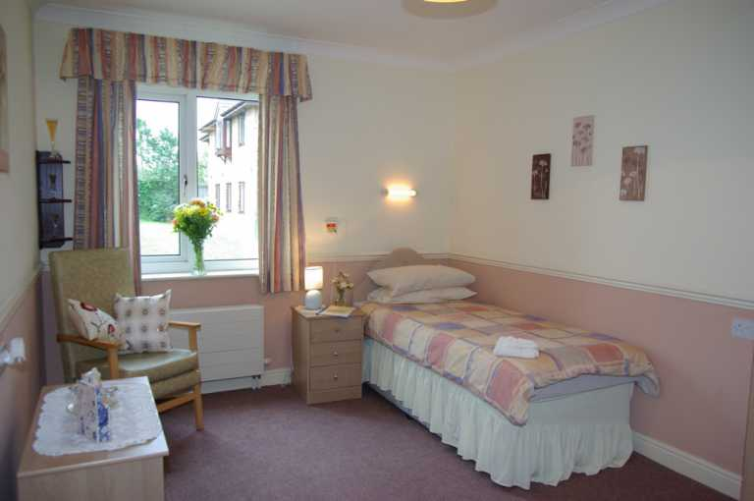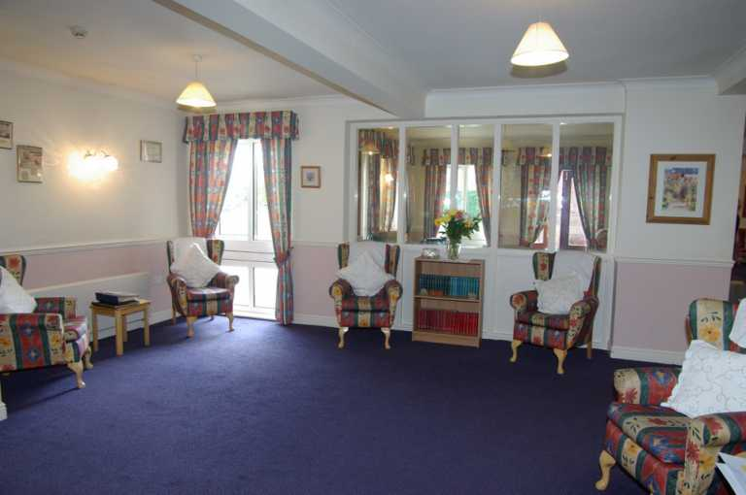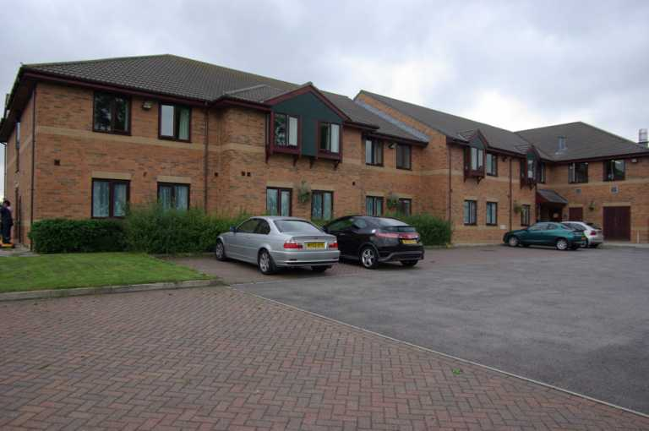

About Cleveland View Care Home.

Cleveland View Care Home is an important part of the community, providing residential and nursing care, in addition to specialist care for those living with dementia, Alzheimer’s and other conditions.

Short term respite care is also provided to help families and loved ones take a break from their caring roles. All our rooms have en-suite facilities.

We promote individual, person-centred care in a relaxed and comfortable atmosphere, encouraging independence, choice and dignity throughout all that we do.

Jenny Stubbs, is the Registered Manager, and together with a strong team of experienced and trained staff, works throughout the day and night to ensure that our residents’ individual care needs are met with dignity and passion and that the care home feels like a ‘home from home’.

We have our own dedicated chef at Cleveland View Care Home, allowing us to cater for individual needs and preferences including specific cultural and religious dietary requirements.

Cleveland View offers car parking, Wi-Fi, is pet-friendly and provides a wide range of other services, such as a full activity of programmes which includes regular outings to local attractions, cafes and garden centres to name but a few.

We have excellent working relationships with local professionals (GPs, Nurses, Commissioners etc.) and have a strong reputation for providing good quality care to our residents.

Commitment

Cleveland View Care home considers its management team and employees to be a very important part of the delivery of a quality service and understands that the future success of the organisation is dependent upon it developing a skilled and educated workforce. Therefore, the organisation places considerable emphasis on the provision of opportunities for staff to study and train to develop their skills further and as a consequence assist them in their career progression within Cleveland View care home.

To assist in offering a high standard of care, the home has the following systems in place.

* A comprehensive set of policies and procedures to assist in the delivery of care used throughout The Fountains.
* Opportunities for staff to develop their skills and careers through training and further study.
* Quality assurance audit tools used throughout all aspects of the business, from care to facilities.
* Regular service users/relatives/ representatives meetings and invitations to people to complete our Satisfaction Survey to enable comments on our service.
* Cleveland View Care home believes that the achievement of the above objectives will result in the continued viability of the organisation thus providing continued security for the people in our homes.

Aims and objectives

* To provide a high standard of individualised care to all its Service Users.
* To ensure that all service users live in a clean, safe environment.
* To treat all service users with care, dignity, respect and sensitivity whilst meeting their individual needs, allowing service users to make informed choices and take risks.
* To respect and encourage the service users right for independence and to endeavour to maintain this wherever possible.
* To care and support service users in a flexible, attentive and non-discriminatory fashion whilst respecting their right for privacy.
* To ensure that each service users’ needs, and values are respected in

matters of religion, culture, race, ethnic origin or sexuality.

* To encourage service users to maintain wherever possible the social and cultural links with the community and to participate in the homes Activity Program.
* To offer service users a varied, nutritious diet ensuring that individual cultural/religious needs are met and where possible respect people’s individual requirements.

Our philosophy of care

It is the aim of Cleveland View Care Home to provide an environment that all service users can regard as their Home, where they are not defined by their age and where prejudice does not prevent them from living fulfilling and active lives. We strive to ensure that each person is appreciated and accepted for their own uniqueness, where their thoughts and ideas are listened to in an environment of mutual respect and where access to an independent advocacy service is provided and encouraged when needed

Our aim is to provide the level of care and support you need to ensure that, as far as possible, you maintain your independence and individuality. Your rights to freedom of choice, privacy and personal dignity will be respected at all times by each of the staff members with whom you come into contact.

Cleveland View is a home in a community setting. Every effort is made to encourage you to remain independent. We will do all we can to provide you with dignity, privacy and respect, ensuring that your spiritual, physical, medical and psychological needs are met in a holistic manner.

You have your own personal Care Plan which is prepared with your involvement, other members of the family and/or those with responsibility for your health, care and welfare. We recognise that each individual is different. Therefore, your care plan will be reviewed frequently to determine the most suitable care for you personally. This ensures that all our residents are being cared for in the most effective way at all times.

A continuous process of training and development of our staff, and the implementation of industry wide best practice, will help to ensure that each resident is getting the best care and service.

You will be encouraged to exercise choice, and procedures are in place to ensure you have access to professional advice and support, where required.

We will encourage, and respect, your right to make and maintain friendships, pursue your hobbies, interests and leisure activities.

Your family and friends will always be made to feel welcome and may visit as often and for as long as you like.

Our fundamental objective is to develop an atmosphere of individual care and attention for our residents to enhance their wellbeing and comfort and thus

enable them to enjoy life to their fullest potential.

Our care team will work closely with you and your family to create a

personalised care plan which is reviewed on a regular basis. We wish your care plan to be as personal to you as possible and therefore value you and your family’s assistance in its development and review.

We believe that helping residents to stay active and make their own

decisions about what they do and how they spend their time, helps them remain happy and healthy for longer.

We believe in tailoring our care to fit the unique needs of each resident.

We aim to make the most of each resident’s strengths, so they can be as fulfilled and independent as possible.

We believe the diversity of residents is our greatest asset and that through the formation of positive relationships they can continue to be part of a vibrant community.

We value the involvement and understanding of residents’ families and friends as we believe the insights, companionship and fun they bring enhances life in our homes for everyone. We believe that teamwork between all employees ensures that each resident receives appropriate assistance to remain as self-reliant and mobile as possible.

We believe in supporting our team by offering training and an environment that welcomes and encourages innovative thinking.

We are committed to our staff, supporting their professional development through training and career progression. This commitment to our staff will allow us to continue to focus on developing standards of excellence and best practice in all our homes thus creating an environment that encourages service users to thrive as individuals.

Vision

To develop services that recognise the changing face of older peoples care and to maintain the philosophy and values of Cleveland View by introducing initiatives that:

* Recognise the uniqueness of each human being whether staff or services user and that each person can contribute to the success of the organisation.
* Are responsive to service users’ needs and expectations
* Seek to continually improve services and quality of care
* Enable us to become employer of choice
* Ensure financial viability and meet regulatory requirements

Core Values

* To create a sense of community and respect for all.
* To ensure that equality exists for residents, staff and visitors
* Service users at the heart of all we do
* Create a Safe and Fair workplace and to provide leadership.
* Encourage and engender teamwork
* Openness, honesty and transparency

At Cleveland View Care Home, we offer innovative care that is of the highest standard, where regard to current research and guidelines on best practice is paramount. We believe that service user’s wellbeing is increased through effective engagement and so we encourage service users to undertake daily tasks, pursue hobbies and maintain strong contacts with friends and families. We encourage the involvement and opinions of families and understand that the wellbeing of service users may well depend on the wellbeing of their family we therefore endeavour to provide support to family members

We will provide care that is non-discriminatory. Our service users will be treated with respect and dignity, regardless of age, sex, race or religious belief. We acknowledge the right of our service users to worship in their own faith, and assistance will be given to make.

Meet the team

**Howard Emanuel**

**Regional Manager**

**Jenny Stubbs**

**Home Manager**

**Claire Fryer**

**Deputy Manager**

**Care Assistants**

Care assistants are active in performing many of the tasks relating to your care. They are there to help and support you with any of the difficulties of daily like that you are currently finding hard to manage on your own. Our care assistants are trained to be understanding and sensitive to your emotional and physical needs. One care assistant will become your key worker so that you always have one person with whom you become familiar.

**Administration**

Much of the ‘behind the scenes’ work, which contributes to the efficient running of the Care Home, is performed by the administrator, who provides invaluable support to all the home.

**Housekeeping**

Our domestic and laundry staff work hard to maintain a clean and fresh environment for you to enjoy. A full laundering service, with the exception of dry-cleaning, is provided in the Care Home. It is the duty of our laundry assistants to ensure there is always a supply of clean clothing and linen for your personal comfort.

**Head Chef and Kitchen Staff**

Because meal times are such an important part of the service we provide, our chefs are skilled and trained in the safe and hygienic preparation of nutritional and appetising meals. The food is freshly cooked on the premises and the menus are planned to ensure that you have a well-balanced and varied diet.

**Maintenance**

Our Maintenance person carries out general repairs and maintenance of the building, grounds, facilities environment. He will also offer assistance in personalising your room, e.g. hanging pictures on the wall.

**Activity Coordinator**

Our dedicated homemaker will help organise activities and outings following discussion with residents and families. A programme of activities is then devised involving the whole care team which reflects the choices and abilities of residents.

“Although each member of staff has a role within the home, the emphasis is very much on teamwork. All our staff are encouraged to continue with Life

Long Learning and to undertake such training to ensure they are competent to meet the needs of our service users”.

Admission procedure

Prior to agreeing to the admission of a potential service user, the Care Manager or a suitably qualified member of his/her staff will visit the intended service user at home or in hospital, unless the service user prefers to visit the Home and is able to do so. At this time, the service users’ needs will be discussed. This will include:

* Review of current care needs
* Assess the extent to which we believe that we can meet the identified needs
* Make initial contact with any other professionals involved in the assessment process
* Assess any specialist equipment required to meet the identified need e.g. pressure relieving mattress

The Care Manager or member of staff shall ensure, as far as it is possible that both the potential service user and their family/representative are fully informed of the scope of services and facilities available at the home with the Service User Guide and Statement of Purpose available.

Cleveland View Care Home will formally write to the Service User to confirm that we can meet their needs. The draft care plan from social services

Once a date for admission and a fee rate has been agreed, the following Home Pack is given to the service user and or their family/representative incorporating the following:

* Home Brochure
* Service User Guide
* Terms and Conditions plus Contract for all service users.
* For Local Authority funded service users, a formal service contract between the Home and the Authority will be agreed in addition to the above.

The fee agreed for any service user admitted to our home will be exclusive of any registered nursing care contribution should this be available following assessment by an external determining nurse. This contribution is only applicable in our homes where nursing care is provided.

The fee for accommodation and personal care, the registered nursing care contribution the method of payment and the person or persons by whom the fees are payable will be fully confirmed upon admission within the terms and conditions and the service agreement.

Prior to admission the pre-admission assessment and Draft Care Plan will be given to the person responsible for the service user’s care.

Within six weeks a placement review will take place for each service user and their care plan will be reviewed. Where a service user has an allocated Case Manager they will organize the placement review and arrange a date, six weeks after admission and as required thereafter. Where there is no Case Manager the key worker or Care Manager will organize and arrange a multi-disciplinary placement review, six weeks after admission and six monthly thereafter. The Care Plan will be reviewed in the Home on at least a monthly basis in addition to the placement reviews. Full involvement by families or advocates is actively encouraged.

Cleveland View care home seeks to ensure that all service users continue to have unrestricted access to all community support services including health, social services, leisure and education and will facilitate such access wherever possible. Our service users have the choice to retain their own G.P. if the service can be

continued or we will assist in locating a new G.P. if required.

Where there is the need for a service user to receive medication, this will be administered by the Nurse on duty in our care homes where nursing care is provided and a senior care assistant in our care homes where nursing care is not provided. We also have a policy that service users may elect to self-medicate and this will be discussed and agreed on an individual basis. Our risk assessment and care planning process will be used for this purpose and a lockable facility would be allocated where appropriate. Our procedures for the receipt, storage and administration of medication will be internally and externally audited.

We recommend all potential service users, relatives and friends to visit the Home to assess our facilities and their suitability. All potential service users are offered the opportunity to move in on a trial basis before they or their representatives make a decision to stay permanently.

Emergency admission procedure

Where possible all admissions should be planned in advance. For the benefit of all service users urgent admissions should be avoided unless enquiries are from a Local Authority representative, Primary Care Team or General Practitioner. All such enquiries will be communicated to the Regional Manager prior to acceptance.

It is essential that discussion takes place between the Care Manager and the Regional Manager to ensure that all resources required are available at the home to meet the needs of an unplanned admission.

Where a pre-visit is not possible due to the immediacy of the admission the Care Manager or Deputy Manager will obtain as much information from the service user or their representative in order to identify the facilities and care required to meet their short-term needs.

The Care Manager or Social Care Officer will ensure, as far as possible that both the service user and their representative are kept informed of the facilities and services at the Home using the Service User Guide and the Statement of Purpose. The full cost of the placement will be agreed prior to admission and written confirmation received prior to admission.

Following admission to the Home the following will be given to the service user/ or their representative:

1. A Home Pack incorporating:

* Home Brochure
* Service User Guide
* A copy of the signed Contract, Terms and Conditions

1. A draft care plan will be drawn up on admission from information given. This will be reviewed within 5 - 7 days of admission.

All other aspects of the admission will remain the same as the Pre-admission procedure.



Catering

Each day, our chef selects fresh, seasonal ingredients and plans tasty, nutritious menus around residents’ individual likes and dislikes, special requirements and dietary needs so please do let us know what your favourite dishes are. If you would like something outside the usual meal times, simply tell one of our care team and something can be prepared for you. Alternatively, if you would like to prepare your own drink or snack please let a member of staff know and they will be happy to show you where everything is. We also offer you and your visitors hot and cold drinks around the clock.

Family and friends are invited to enjoy subsidised meals and drinks with you and if there’s a birthday or other special occasion you’d like to celebrate with them, please let your carer know in advance so that we can arrange party menus and celebration cakes etc.

In addition to dining in our restaurant, you can also choose to eat in your room if you would prefer. Food is also available from the coffee shop. Please let a member of the team know if you would like to pre order food.



Activities, excursions and hobbies

Our home has an outstanding balance of in-house and external visitors in order to provide stimulating and enjoyable activities for our residents.

We have a range of group and individual exercises from sing-a-longs to basic exercise, quizzes, movie evenings and planned events.

We review our activity programme often to cater for the wishes of our residents and believe that providing a motivating and exciting environment greatly enhances the quality of life for all involved. We encourage visitors, relatives and friends to participate in activities and outings as much as possible.

Every week, our Homemaker will prepare a list of organised activities and excursions for you to choose from. These typically include tea dances, bridge, crafts and bowls as well as art and music related activities. Most of our entertainments such as the film screenings at our cinema are free of charge.

We hope you’ll take full advantage of these fun experiences. All you have to do is let your carer know what interests you. Your family is always welcome to join in too.

If you’d like to keep up a hobby or interest of your own, please tell your carer and they will make the necessary arrangements.

Rights of service users

1. Privacy

* Staff will knock and wait before entering a service users’ room.
* Staff are aware of the need to maintain confidentiality.
* Intimate personal care will be undertaken in private and discretely.
* Service Users will be provided with individual storage in their bedrooms which are locked, and their bedroom door can also be locked

2. Dignity

* All communication with service users is respectful.
* Service users are called by their preferred name.
* Open visiting is welcome and arrangements for privacy are in place.
* Private access to a telephone is available.
* As far as possible a resident’s preference to receive care from a male or female is respected.

3. Rights

* Service users are able to voice their views at service user/relative/ representative meetings.
* Service users and/ relatives/ representatives are consulted when planning their care.
* Service users have a right to take risks.
* Complaints are treated with sensitivity and service users should be able to voice concerns without fear of reprisal.
* Service users give informed consent to treatment and have a right to refuse care/treatment.
* Service users are allowed to bring their own furniture and possessions of their choice.

4. Choice

* Service users may choose the time they rise and go to bed, the time they get washed and dressed, the number of showers/baths they have and choose where they eat.
* Service users have a choice of meals.
* Service users are allowed and encouraged to choose their own
* General Practitioner.
* Service users are consulted when drawing up new menus.
* Service users are able to choose how to and will be able to choose from a wide range of educational, social and leisure activities.

5. Independence

* Service users will be encouraged to maximize their ability to self-care and undertake daily living tasks.
* Promote the possibility to establish and maintain contact away from the home

6. Fulfilment

* Service users are encouraged to fully realize their personal aims.
* Service users are encouraged to fully realize their full potential.
* Service users are happy and contented with their quality of life.

7. Rights of the Home and its Occupants

* Service users must respect the property and belongings of others.
* Service users must respect the privacy of other service users within the home.
* Service users must respect the rights of other people and allow them to continue in their beliefs and to make their own choices.
* Service users must respect other service users and staffs’ ethnic background, language, culture and faith.
* Service users must consider other service users in the home and not cause unnecessary noise, pollution or disturbance.

Fees

Here at Cleveland View Care Home, we pride ourselves on our fair and competitive prices within the local area. We operate a transparent person cantered pricing schedule, based on your individual needs.

A full assessment of your needs will be carried out prior to admission to determine what your individual needs might be, how we may meet these needs and the cost of care.

We understand that needs can change over time and we continue to assess these on an ongoing basis to ensure that all our residents receive the care they need at all times.

Should you be entitled to funding by a Local Authority, the NHS or any other third party, this will count towards the overall weekly fee and you or your representative will only be liable to pay for any portion of the cost not covered by the third-party funding.

Our price list is based on your individual category of care and dependency level and covers most circumstances. In unique circumstances it may be necessary to adjust the price to cover a very specific need (e.g. one to one care).

Contact us

Please do feel free to contact us with any further queries:

**Drop in:**

Cleveland View Care Home,

Cargo Fleet Lane,

Middlesbrough,

TS3 8NN

**Ring us:**

01642 244977

**Email us:**

Clevelandmanager@bodcare.co.uk

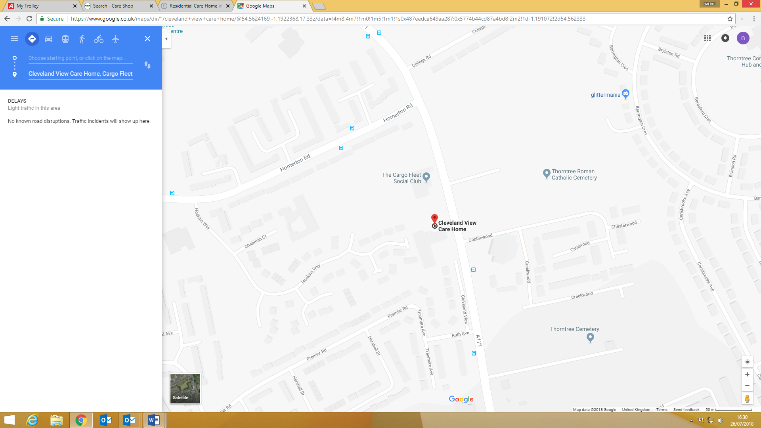

We will be delighted to meet you and we warmly look forward to welcoming you.

**Flowchart for reporting abuse**

**Abuse discovered or suspected**

**Make safeguarding referral**

**Is the adult at risk of immediate danger or in need of emergency medical treatment?**

**And/or has a crime been committed?**

**And/or is there a need to protect forensic evidence?**

**Is anyone at risk of harm e.g. another adult or child?**

**YES**

**Contact emergency services**

**NO**

**Contact the Local Authority Social Work team for advice**

**NO**

**Safeguarding adults issue confirmed?**

**YES**

**Document all discussions held, actions taken, decision made including who was informed and who was spoken to**

**All information to be passed to designated professional for safeguarding on next working day**

**Record incident on incident reporting form**

# COMPLAINTS PROCESS

Complaints Procedure

If you wish to make a formal complaint about any aspect of our service delivery, then please speak with the Care Home Manager in the first instance.

The Care Home Manager will ensure that your complaint is heard and dealt with as quickly as possible.

If you would like to have a copy of our Complaints Process, then please ask for this in the main office.

##### The Care Home Manager for **CLEVELAND VIEW CARE HOME** is: **JENNY STUBBS.**

If your complaint is concerning the Care Home Manager, then please contact the Regional Manager.

The Regional Manager for CLEVELAND VIEW CARE HOME is: HOWARD EMANUEL

[**hemanuel@bondcare.co.uk**](mailto:hemanuel@bondcare.co.uk) 0208 202 2277

If you remain unhappy with the outcomes of any response you have received, then please contact the Operations Director of Bondcare in writing at:

Bondcare House

18 Lodge Road

London

NW4 4EF

Care Quality Commission

Gallowgate

Newcastle upon Tyne

NE1 4PA

At any time, you can directly contact the following to share your complaint:

**Insert details of your Local Authority:**

A register of all complaints is kept within **NAME OF CARE HOME**